Instruction on preparing an abstract for the XVI ISSRNS conference
X.Y. Presenting Author¹*, Z.V. Author¹, C.T. Author^{1,2} and H. Author²
¹Lord Howe Island University, Lagoon Road 1, Lord Howe Island NSW 2898, Australia
²European Synchrotron Radiation Facility, B.P.220, F-38043 Grenoble Cedex, France
*e-mail: presenting_author@det.nsw.edu.au

The preferred length of the abstract is one page with 3 cm margins on each side. Preferred font type is Cambria. Size of the font used in the abstract text is 11 pt, whereas the font size in figures, acknowledgements and references is 9 pt.
Due to the small format size, please do not put in a regular abstract more than two figures (see Fig. 1). In this¹ part of text we present² the use of references³.
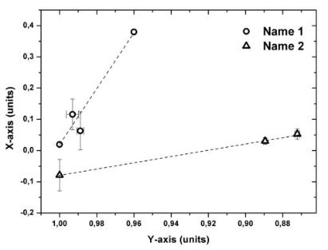
The International School and Symposium on Synchrotron Radiation in Natural Science will be held on 25-30 May 2025. The programme of the Symposium will comprise invited lectures (40 minutes), oral communications (20 minutes) and poster presentations. The official language of the meeting is English.
The abstract will be published in the electronic version of the special issue of Synchrotron Radiation in Natural Science¹ – the bulletin of the Polish Synchrotron Radiation Society.
Figure 1. Figure name

The abstracts should be submitted via the online submission system. Filenames should follow the style of ‘surname_forename_ISSRNS2025_contribution.pdf’. Names should be written with standard Latin characters, while contribution indicates the preferred presentation format: oral, poster, lecture. The example of a correct file name is ‘Lem_Stanislaw_ ISSRNS_2025_oral.pdf’.
Acknowledgements: This project was financed by …
References
1. https://biuletyn.synchrotron.org.pl
2. S. V. Krivovichev, Angew. Chem. 53 (2014) 654.
3. P. Murck, New age of synchrotron studies (Sun Editors, Honolulu 1891)

